Kurt Ramos
Dr. Esther Milu
ENC6740 – Global Black Rhetorics
2 May 2023
Exploring the Generative Power of Nommo (Beyond Names and Words)
Africans, as well as their kin and descendants across the global diaspora, understand the significance behind the act of creating names and communicating words like no other. Nommo is an African concept and term that encapsulates the power of the spoken word and its meanings within. The concept of Nommo originates from the Dogon people, who have resided in the nation now known as Mali. According to one of the Dogon people’s creation myths, Nommo originated from their god, Amma, also known as Amen. Amma/Amen, who is also credited by the Dogon as the creator of life on Earth, used Nommo in order to develop order within the universe. Once this universal order was achieved, Amma then imbued humanity with Nommo in the form of the spoken word, so that humans could also bring about order in their lives and back to the universe. Nommo, the power of the spoken word, therefore carries a very significant spiritual and social importance among not just the Dogon people, but Africans at-large. Some Africans and those belonging to the global African Diaspora even believe that Nommo can determine the choosing of children’s names, or that it can bring death into their community.
This exploratory essay takes a concise yet detailed look through the concept of Nommo, plus its various applications across African and Afro-Diasporic cultures. First and foremost, I will attempt to explain other scholars’ definitions of Nommo, since the shared belief in the power of the spoken word is not exclusive to the Dogon people. Neither is Nommo limited to naming practices, although these interesting practices will also be explored. With these scholarly explanations in mind, I will then conduct a trans-national analysis of Nommo as a (global) Black rhetorical practice. My investigation of this practice and others will be guided by questions serving as transitions into this section of my paper and the following sections. This trans-national analysis will initially be centered on the cradle of civilization we call Africa, before making sense of how Nommo additionally influences Afro-Caribbean and Afro-Latinx livelihoods. Following a literary North Star, I will describe how African-Americans have employed Nommo, alongside other rhetorical practices, within a nation that became the wealthiest in history off of their forced labor. Finally, I will show how the Black rhetorical practice of Nommo translates on a global and universal scale.
Black Scholars on Nommo
The culturally shared belief in Nommo among various African cultures has led to scholars of Africana Studies and Black Rhetorics to further define what Nommo entails in various interpretations. Where, in particular, does the power of the spoken word, and by extension Black rhetoric, truthfully lie? Within the context of arrangements of the spoken word, where does the sense of power come from? The African-American activist and scholar Maulana Karenga, who was formerly known as Ronald McKinley Everett, maintains that the power of the spoken word comes from “communal deliberation, discourse, and action, oriented toward that which is good for the community and the world” (Karenga 3). Elaborating on this, he goes on to add that those engaged in Nommo are producing “a reaffirmation of our Africanness and social justice tradition” (Karenga 7). Another African-American scholar, Molefi Kete Asante, who was formerly known as Arthur Lee Smith, defines Nommo as “the fundamental, as well as the fashioning, instrument of traditional African society” (Asante 81).
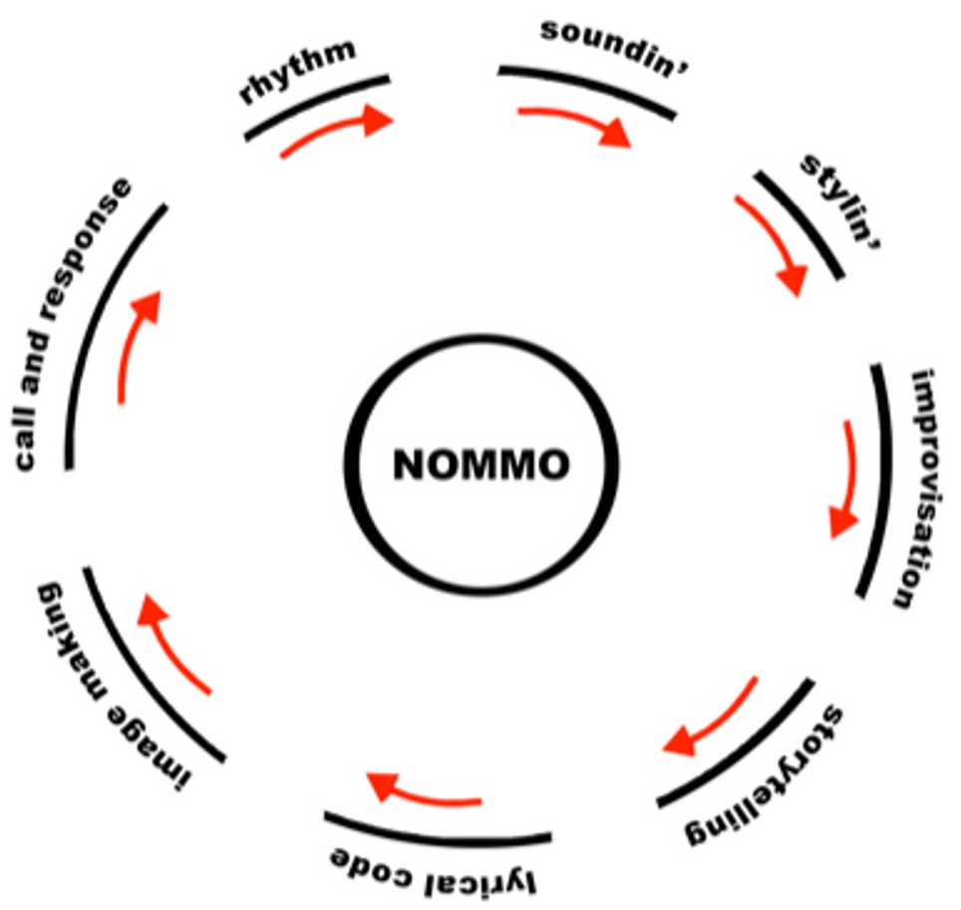
Figure 1. A diagram showing the circular and continuous rhetorical rhythm of Nommo, taken from Keith Gilyard’s Introduction to African American Rhetoric(s): Interdisciplinary Perspectives, edited by Elaine B. Richardson and Ronald L. Jackson II.
Meanwhile, the Afro-Caribbean scholar Kamau Braithwaite defines Nommo as “the atomic core of language…something that is very much present in all folk cultures, all pre-literate, pre-industrial societies” (Braithwaite 90). This definition can be considered a secularized version of the Dogon creation myth; much like the universe ever-expanding, Braithwaite correctly adds that “language was and is a creative act in itself” (Ibid). Figure 1 depicts the many ways that Nommo (re-)generates the proliferation of language; it is a life cycle diagram that both centers and presents Nommo as a life force. We can consider these many ways and meanings as life forces of their own, some of which will be prominent within African and Afro-Diasporic cultures – and explored, in greater detail, in the following trans-national explorations below.
Nommo within the Motherland of Africa
Maulana Karenga, in his essay titled “Nommo, Kawaida, and Communicative Practice: Bringing Good into the World”, emphasizes the ongoing creation of meaning among communities and in alignment with ancestral African values. To make his case contrast with (and away from) dominant European philosophies that favor individualistic thinking and perceiving, Karenga provides us with a crash course on two Ancient Egyptian concepts: ‘medu nefer’ (alternately written as mdu nfr) and ‘maat’. The concept of “medu nefer” roughly parallels with the Ancient Greeks’ rhetorical appeals of ethos, logos, and pathos; of the three, medu nefer primarily aligns with ethos. Medu nefer roughly translates to “good speech”; but in an instance of linguistic connectedness, this term translates in Swahili to “morally good” (Karenga 11). For the Zulu people of present-day South Africa, medu nefer translates to “aesthetically beautiful”. (Ibid). On the other hand, maat is a term that roughly translates to “rightness in the world”. When maat was featured in Ancient Egyptian texts, like The Sebait of Ptahhotep and The Book of Khunanup, the term described a combination of morality found in law, nature, and the divine. Maat was considered to be “the moral ideal in Ancient Egypt” (Karenga 12). This three-part moral ideal also roughly corresponds to medu nefer as the Ancient Egyptians’ equivalent to the Ancient Greeks’ three types of rhetorical appeals.
Besides the belief that Nommo is a reaffirmation of African social justice, he adds that “African rhetorical practice is a rhetoric of possibility…it is an active call to counsel and collaboration in the ongoing quest for effective ways to solve human problems, [and] elevate the human spirit…” (Karenga 6). These calls to counsel and collaboration are present in his referring and deferring to fellow scholar Molefi Kete Asante, and in Karenga’s explanations of ‘kawaida’. Kawaida, a word that is Swahili for tradition, is a contemporary philosophy which synthesizes African cultures’ interconnectedness with their potential as a “rhetoric of community” (Karenga 10). Asante argues that
“[T]he African sees the discourse as the creative manifestation of what is called to be. That which is called to be, because of the mores and values of society, becomes the created thing, and the artist or speaker, satisfies the demands of society by calling into being that which is functional.” (Asante 75)
In other words, Asante calls for Africans and African-descended peoples to strive towards upholding Kawaida by engaging in Nommo. But how do these spiritual and philosophical beliefs translate to people storytelling and oral traditions?
Griots (and their female counterparts, the griottes) are perhaps the best examples of Nommo personified among traditional African cultures. Griots and griottes serve their communities not only as storytellers, but as diplomats, genealogists, and singers, among other important roles. These intelligent members of African society bridge a crucial link between past and present through Nommo, keeping alive centuries of myths and traditions for those blessed to hear and receive their words and wisdom. One example of a modern-day griotte who bridged the cultural gaps between past and present, is the late Bako Dagnon, who served the rural Mandika people of present-day Mali until her passing in 2015. Dagnon’s role as a griotte (also called a djeli among these people) was highlighted in a film titled Growing into Music in Mali. Prior to Dagnon’s interview, another Mandika woman declares that Nommo and the talents of a djeli are “suckled from their mother’s milk…That’s how it’s passed on. It’s already suckled in; therefore, there is no problem” (Banal). During her interview with the film’s director, Bako Dagnon, in reference to her grandchildren, states that she tells them tales “because tales open up children’s minds. With tales, you can teach them the difference between good and bad” (Ibid). After launching into a sung story about a woman who flees home and walks into a pack of hyenas, Dagnon proclaims that “There is no song without meaning. All the songs I’ve learnt, I’ve learnt their meaning as well” (Ibid). Going beyond an African equivalent of Aesop’s Fables, Bako Dagnon educates child and adult listeners alike by comparing the griottes’ techniques to repeating the eating of buffalo meat. This metaphor summarizes the concentration and dedication needed to become a steward of the spoken word among the Mandika and other African cultures.
Nommo among Afro-Caribbeans
When Africans were taken as slaves to the Caribbean and the Americas, did they lose their ability to practice Nommo? Despite involuntary permanent separation from the African continent and the severing of Africans from their biological families and tribal bonds, Africans in ‘the New World’ would go on to engage in Nommo. Their utilization of Nommo took on roles and rhetorics of resistance, as they exchanged and combined cultural beliefs and rhetorical practices with indigenous islanders and mainlanders alike, marking the emergence of the global Black diaspora.
The Afro-Caribbean poet and scholar Kamau Braithwaite, who lived and died in present-day Barbados, made sure that Nommo, as adapted and practiced by Afro-Caribbeans, would not be overlooked in contemporary Black scholarship. Throughout his lengthy essay, titled “The African Presence in Caribbean Literature”, Braithwaite illustrates the rhythm within Nommo through excerpts of poetry. Rhetors of Afro-Caribbean literature may not
“know very much about Africa necessarily, although he reflects a deep desire to make connection. But he is only saying the word “Africa” or invoking a dream of the Congo, Senegal, Niger, the Zulu, Nile, or Zambesi. He is not necessarily celebrating or activating the African presence.” (Braithwaite 80-81)
So how can an Afro-Caribbean version of a griot activate the African presence? They can activate the African presence through Nommo’s function as “a kind of conjuration/divination” (Braithwaite 91). Africans and Afro-Caribbeans alike “feel a name is so important that a change in his name could transform a person’s life” (Ibid). They also can incorporate “sound-symbols” into their chants and religious practices. Sound-symbols such as the Jamaicans’ “bangarang” and “patoo”, or the Barbadians’ “bruggalungdung”, conjure up divine powers that preachers in America invoke with less onomatopoeia.
The Afro-Caribbean’s desire for connection to the cradle of civilization extends beyond poems and sound-symbols. From a review of Puerto Rican author Carmen Montañez’s book Pelo bueno, pelo malo, Thomas Wayne Edison notes the significance of hair and ‘muntu’ among Afro-Caribbeans and Afro-Latinas. According to Edison, “Muntu is a Bantu term meaning connection between the living and the dead” (Edison 625). This connection is expressed and shared by Afro-Caribbeans, for example, in contemporary Día de los Muertos (Day of the Dead) festivities. Edison interprets muntu as something that parallels with the Dogon creation myth and the cultural values of native Americans/Caribbeans.
While I have not finished reading Pelo bueno, Pelo malo, which translates in English to “Good hair, Bad hair”, I can provide a rough summary of this excellent Afro-Caribbean tale. The characters of this novel deal with colorism, in that the Afro-Caribbeans are shunned out of socio-economic mobility, whereas the more Spanish and light-skinned people are allowed to have more privileges. The protagonist, Amarilis, practices rituals that invoke her Muntu ancestors, causing them to appear in her dreams. From there, these Muntu employ Nommo to help Amarilis live a life of healing and justice. Much like their African and Black-skinned relatives, Afro-Caribbeans’ bodies and expressions are both reviled and objectified to uphold a status quo where having fairer skin gives unfair advantages. Pelo bueno, Pelo malo invites us to scrutinize this status quo and bear witness to the strength of Nommo’s transformative rituals in mind and body.
Nommo among African-Americans & Africans in the United States of America
How do Black people in the United States, a nation still believed to be a ‘melting pot’ of cultures, engage with Nommo and African rhetorical practices? Foregrounding their analyses of Kawaida and Nommo within the physical and digital geography of the United States, Keith Gilyard and Adam Banks present a constructively critical lens upon history in their book On African-American Rhetoric. In addition to Nommo, this book describes several other African rhetorical forms and genres such as Jeremiads, slave narratives and spirituals. The authors’ analysis of Nommo begins in the 2nd chapter, where they cite poet James Whitfield’s abolitionist writings. Whitfield wrote of the abolitionist rhetor, “Rather than adhering to any injunction against poetry, he protests through poetry in the name of truth and as the truth” (Gilyard and Banks 11). Whitfield is just one of several exemplary African-American figures who embody this visionary aspect of Nommo.
Metonyms, words that can be used to describe something else that is closely related, factors into Nommo, too, in that the words ‘Africa’ and ‘Ethiopia’ were invoked as not just the physical land, but the promised land of a yet-to-be-liberated people. For example, in reference to Asante’s book The Afrocentric Idea, Asante’s meaning of “the African World” refers to both Africa the continent and the diaspora (Gilyard and Banks 46). Remarkably, metonyms even factor into the very names of the abolitionist Sojourner Truth and the author Alice Walker, who both share identical names: ‘Sojourner’ is an archaic term for a walker, and ‘Alice’ is Ancient Greek for truth. This truth can also be found, in the form of call-and-response, in the Black church: Jack Daniel and Geneva Smitherman write that communications in church mark “the beginnings of process, i.e., the call by God and the man’s response by taking up the ministry” (Daniel and Smitherman 35). In the secular realm, a hierarchy “is headed by the heroic man of words in the form of poolroom, barbershop, or street corner rapper” (Daniel and Smitherman 37).
George Yancy extends upon Geneva Smitherman’s scholarship and the power of nommo among oppressed African-Americans in his essay “The Social Ontology of African-American Language, the Power of Nommo, and the Dynamics of Resistance and Identity Through Language”. Nommo’s potency is best explained by Geneva Smitherman, who describes nommo as “life force itself…no medicine…of any sort is considered effective without accompanying words” (Yancy 290). Smitherman, who is referred to as ‘Docta G’ by Yancy, additionally explains that “The pre-slavery background was one in which the concept of Nommo, the magic power of the Word, was believed necessary to actualize life and give man mastery over things” (Ibid). In spite of the many sociolinguistic traumas inflicted upon Black people, past and present, Nommo remains “capable of concretizing the Black spirit in the form of action…necessary within the framework of a contentious and oppressive alien cultural environment” (Yancy 291). Nommo takes on a triumphant form in the Reverend Dr. Martin Luther King’s homilies and Muhammad Ali’s proclamations of being ‘The Greatest’ athlete. Although the scope of Yancy’s essay does not touch upon the multiple civil rights and Black Power movements of the 20th century, and was written prior to the emergence of Black Lives Matter, Yancy (through Smitherman) nonetheless pinpoint other manifestations of Nommo in African American Vernacular English (AAVE) and the prominence of rap music. People’s utterances of AAVE or rap verses underlie the function of Nommo “as a site of rupture” (Yancy 293). This rupture site, and the disruption of more conventional (i.e., White) language progresses Nommo as resistance, and promotes solidarity with Black people of different backgrounds.
Nommo can be utilized not just cultural or racial differences; with speeches from powerful politicians like former U.S. President Barack Obama, nommo and its various forms can cut through political differences, too. Obama, who was subjected to racist attacks on his character due to having a Kenyan father while running for President of the United States, nonetheless managed to convince millions of Americans that as the first Black president, he and his policies would embody “Hope” and “Change”. Interestingly, in Sheena Howard’s article “Manifestations of Nommo: Afrocentric Analysis of President Barack Obama”, Howard notes Obama’s use of silence to indicate the rhythm of his rhetoric, particularly with students at Howard University. For these students, “President Obama’s use of rhythm planted a seed of excitement in the audience as his speed increased…provoking the audience to emerge in cheers, clapping, and standing ovations as he harbored a sense of emotion within the audience” (Howard 743). In his ‘Commander-In-Chief’ role, Obama articulated the need for change with an air of hope, alluding to the myths which have made America the prevailing power it has been, yet also alluding to the real struggles past Black public officials and speakers like Thurgood Marshall faced. Obama, as a man speaking to God-fearing Black and White people, frequently invoked myths and Biblical religious narratives as a way to connect and relate with his fellow Americans. His repetition of certain phrases such as “Be strong and have courage” were deployed to rouse the passions of his (Black) audiences into taking substantial action beyond the mere (but not meager) performances of the President.
Global & Rhetorical Impacts of Nommo Across the Black Diaspora
The Nigerian scholar Moses Oludele Idowu characterizes Nommo as “the fort of preachers, the defense of lawyers, crown of great leaders, the glory of orators, tool of teachers, and the glue that binds lovers to each other” (Oludele 2).
Howard University professors Felicia Walker and Viece Kuykendall contribute to this oratory glory by exploring “Manifestations of Nommo in Def Poetry”. Throughout this article, and the syndication of the television show Russell Simmons Presents Def Poetry, readers, listeners, and viewers alike are participants in Nommo’s generative power. The performance aspect of Nommo’s orality is uplifted most strongly here, relative to the previously reviewed articles. Although Def Poetry was a program based and filmed in the United States, its poetic participants and subject matter busted a move (and a groove) with Afro-Caribbean, Afro-Latino, and Afro-Arabic cultures, alongside the dominant African-American culture. The broadcasting of words and song, whether through radio or by television, and from people animated with passion, has expanded nommo and Afrocentricity unlike any other genre. Jahn and Asante are again continually acknowledged in their testifying of Nommo as life-force and “word seed” (Walker & Kuykendall 234). From each of Def Poetry’s spoken-word pieces and raps, we can conclude that “Nommo is more than simply telling the story. Nommo gives the story a heart, lungs, and hands to help the listener interact and understand the importance of the story” (Ibid). Behind each performance and every episode of Def Poetry lies an additional form of Nommo, which Daniel and Smitherman extensively documented: the call-and-response. Repetition, soundin’ out, and stylin’ of each poet effectively progress the poet’s intentions from call and response towards generating life among the audience and culture. Thus, Nommo propelled the success of Def Poetry, and continues to propel the African oral tradition from storytelling, sermons and spirituals to rap songs.
Nommo has additionally been transmitted through cultures across the global Black diaspora within the universal and embodied languages of dance and music. Because dance and musical performances are often accompanied by ordered words, the rhetorical power of the word is made dynamic across each and every performance. For example, Kamau Braithwaite wrote that “the whole living tradition of the calypso is based on” Nommo being used in “tea meetings and preacher/political orations” (Braithwaite 92). Musical manifestations of Nommo can be found in African artists outside of the rap and hip-hop genres as well. One example comes from the Nigerian drummer Babatunde Olatunji; his song “Jin-go-la-bah” (which translates to “Do Not Worry”) features a staggered chorus engaged in call-and-response, and chanting the title track, all to the beat of djembe drums.
Conclusion
Every human being possesses the capability to communicate. Similarly, everybody possesses a name that anchors our identities and personhood, which our communications and expressions are associated with. From the moment we were born onward, our capacity to communicate through language helps us better observe and participate with other human beings within a society. When words are spoken from our mouths, we are either deliberately or unknowingly transmitting, as well as preserving, pieces of our cultures to others, irrespective of whether or not they share our cultural background.
This essay has sought to make abundantly apparent the creative, generative, and life-affirming ways in which Africans and their diasporic descendants have utilized nommo. Nommo, the power of spoken words, has been wielded to strengthen the interconnectedness of Black cultures through centuries of oppression, in Africa and around the world. It has taken on the form of call-and-response to generate consensus across artistic and rhetorical performances, particularly in religious gatherings and in music. Additionally, people who have engaged with nommo have successfully provoked calls to action throughout the existential exigencies of slave revolts and civil rights movements. As a wise friend of mine once told me, “The meaning of our lives is to give our lives meaning”; as a result of Black people’s rhetorical practices, we can both name and explain what (plus who) is needed, in order to develop self-determination and societal cohesion.
The cultural practices and applications of nommo should be more openly credited for and contemporary Western culture. I believe this should be the case because the power of the spoken word has done much to provide African peoples and Afro-Diasporic communities with the resilience and tenacity to empower other communities and cultures beyond their own, including those which are not Black. How can those of us without genealogical roots to Africa incorporate Nommo in our lives and struggles? To use Nommo effectively, we must use (or at least consider) the Black rhetorical practices outlined within this paper. Irrespective of the names which we were assigned at birth, or our individual strengths and weaknesses when it comes to communicating with words, nommo is indeed a life force that has generated, is generating, and will continue to generate much good in our world.

Works Cited (in MLA)
Asante, Molefi Kete. The Afrocentric Idea. Temple University Press, 1988.
Banal, Michele. The Voice of Tradition: Bako Dagnon and Her Family. YouTube, Growing Into Music, 2021, www.youtube.com/watch?v=Xmbf0_DUOg0.
Daniel, Jack L., and Geneva Smitherman. “How I Got over: Communication Dynamics in the Black Community.” The Quarterly Journal of Speech, vol. 62, no. 1, 1976, pp. 26–39, https://doi.org/10.1080/00335637609383315.
Edison, Thomas Wayne. “Restored Roots: Muntu as a Healing Agent in Pelo Bueno, Pelo Malo by Carmen Montañez.” Hispania, vol. 100, no. 4, 2017, pp. 624–35. JSTOR, https://www.jstor.org/stable/26387813. Accessed 29 April 2023.
Gilyard, Keith, and Adam J. Banks. “Historical Overview of African-American Rhetoric.” On African-American Rhetoric, Routledge, Taylor & Francis Group, New York, 2018, pp. 10–28.
Gilyard, Keith, and Adam J. Banks. “Rhetorical Theory.” On African-American Rhetoric, Routledge, Taylor & Francis Group, New York, 2018, pp. 46–70.
Howard, Sheena C. “Manifestations of Nommo: Afrocentric Analysis of President Barack Obama.” Journal of Black Studies, vol. 42, no. 5, 2011, pp. 737–50. JSTOR, http://www.jstor.org/stable/41304552 . Accessed 29 April 2023.
Idowu, Moses Oludele. “International Colloquium/ Festival to Celebrate 48 Years of Solo Performance in Nigeria by the Department of English and Literature, Nigerian Turkish Nile University, Abuja.” Artillery Publications, Words of Power, Power of Words: The Spoken Word as Medium of Vital Force in African Cosmology, 6 May 2014, www.academia.edu/8300744/Words_of_Power_Power_of_Words_The_Spoken_Word_as_Medium_of_Vital_Force_in_African_Cosmology. Accessed 29 Apr. 2023.
Karenga, Maulana. “Nommo, Kawaida, and Communicative Practice: Bringing Good into the World.” The Global Intercultural Communication Reader, edited by Molefi K. Asante et al., Routledge, New York, 2014, pp. 3–22.
Walker, Felicia R., and Viece Kuykendall. “Manifestations of Nommo in ‘Def Poetry.’” Journal of Black Studies, vol. 36, no. 2, 2005, pp. 229–47. JSTOR, http://www.jstor.org/stable/40034330. Accessed 29 April 2023.
Yancy, George. “Geneva Smitherman: The Social Ontology of African-American Language, the Power of Nommo, and the Dynamics of Resistance and Identity Through Language.” The Journal of Speculative Philosophy, vol. 18, no. 4, 2004, pp. 273–99. JSTOR, http://www.jstor.org/stable/25670529. Accessed 29 April 2023.

This is a general definition of Nommo paraphrased from African-American scholar Maulana Karenga, whose work I will analyze later in this essay.
My brief explanation of the Dogon creation myth, and context for the concept of Nommo, comes from a discussion I had with Dr. Esther Milu and this Encyclopedia Britannica entry: https://www.britannica.com/topic/Amma.
Karenga also created the December-January holiday of Kwanzaa. The holiday’s name comes from the Swahili phrase matunda ya kwanza, which is Swahili for “first fruits”.
Arthur Lee Smith would go on to change his name to Molefi Asante after a librarian at the University of Ghana in Legon thought the former name, published as such on one of Asante’s books, belonged to a white man.
The name ‘Maulana’ is Swahili and Arabic for “master teacher”.
The name ‘Karenga’ is Swahili for “keeper of tradition”.
The name ‘Molefi’ comes from the Sotho people of present-day Lesotho. It roughly translates to “One who gives and keeps the traditions”.
‘Kete’, as a noun, is Swahili for dice; as an adverb, it roughly translates to “quietly”. In the Yoruba language, ‘kete’ signifies everyone or everything.
‘Asante’ is derived from the Twi language, which is mainly spoken by the Asante (a.k.a. Ashanti) people of present-day Ghana.
Also quoted on page 10 of Karenga’s essay.
The name ‘Kamau’ derives from the Kikuyu people of present-day Kenya. It translates to “quiet warrior”.
The Bantu people consist of the majority Black people residing in present-day South Africa.
“Djembe” roughly translates to the phrase “Gather together in peace”, derived from the Bambara people of Mali.

